Home analysis – 1
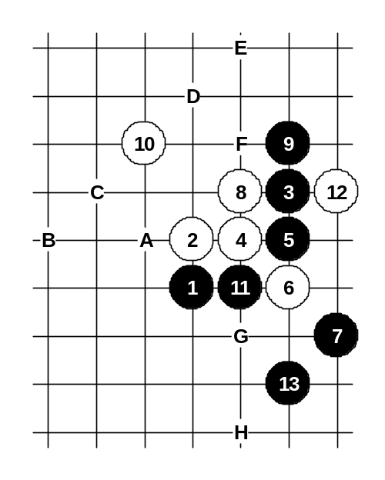
D3 opening

For the advanced class.
In the previous issue I introduced my home analysis about the popular variant of D3 opening that was also played in the match Meritee-Nakamura. In the previous home analysis I suggested this 10th move as a new idea of white development but recently I have found very powerful moves for black in this variant. Moves 11 and 13 are very active. Practically white cannot stop black force in lower side passively (see moves G, H) because black is already too strong there. Therefore white’s only hope is the counter-activity (see moves A, B, C, D, E, F). After long analysis I have made the conclusion that the white’s counter-activity does not bring any success either. So I can conclude now that the 10th move is not good for white and therefore white should play in the old style 10-G. See my analysis in the following diagrams.
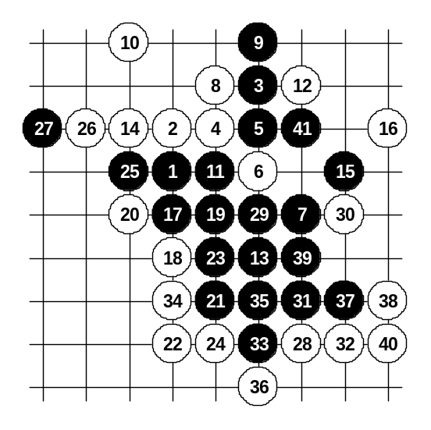
A:
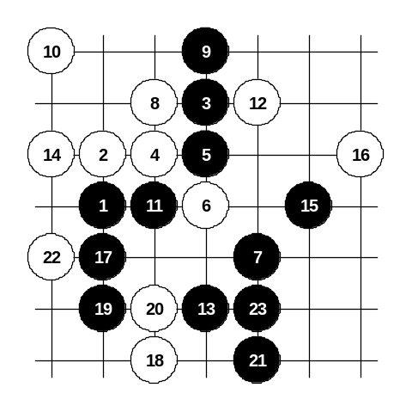
This 14th move seems to be the most natural but here the black can find very logical plan for attack and the win comes quite easily. White attempts the counter-activity with move 20 but black neutralizes it with moves 21, 23, 25. After that white is unable to stop the black force in lower side. You can try some other 28th moves but black wins there even faster. →

← Another 18th move. White puts all the hopes on counter-attack again but actually white does not have nay VCF after 22nd move because of nice black cut-line that stops the VCF attempt. Therefore simple 23rd move wins here. If 20-g6 then 21-23.
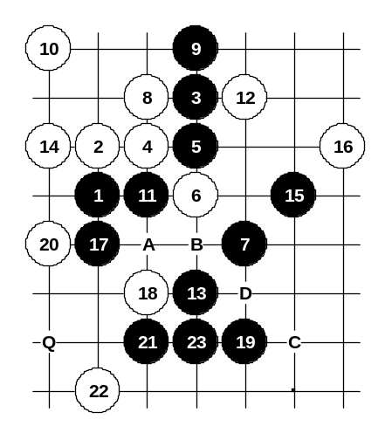
The third choice of 18th move. Move 19 is the only way do develop black’s attack and after active 20th move it seems that white counter-attack will be successful this time but the beautiful moves 21 and 23 (!!) will create another cut-line that will control the black’s VCF at point Q. After that black wins by his own VCF – A, B, C, D. This diagram is very useful lesson about playing in active style. →
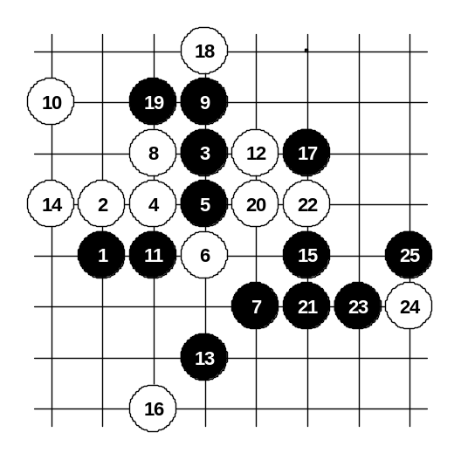
← As a result, white is forced to stop the black three from the other side in move 16. Here the black win is very easy – 17 !
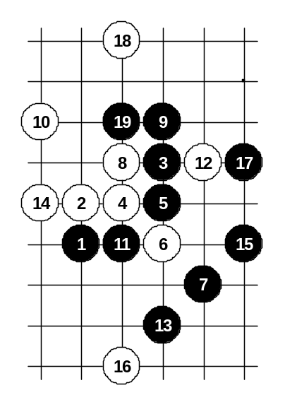
Passive stop is useless here, therefore white tries an active 18th move. The move 19 neutralizes all white’s counter-activity and now black wins simply and quietly on the right side.

Here is one more attempt for active fight in move 18 but it is hopeless too. Simple 19th move cuts the white’s VCF attempt. Black will remain the tempo because of black’s VCF threat. →

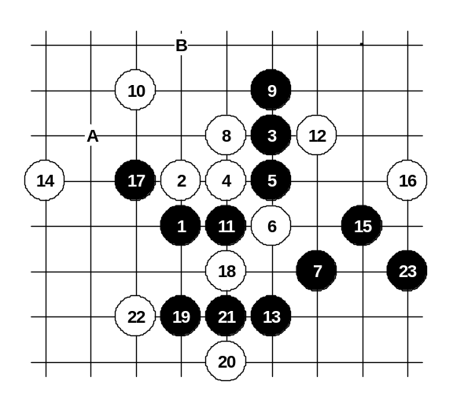
←B:
← Another 14th move contains a trap that you can see in the next diagram. First we look at 16-stop in upside. If 18-A then 19-B and black has VCF threat. In case of 18-18 black simply wins below with move 19.

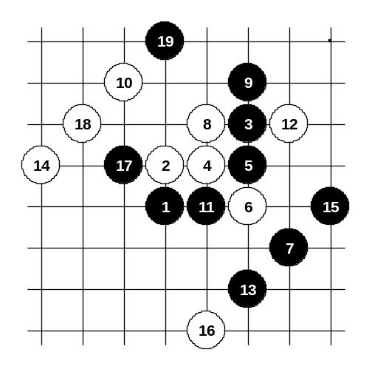
Here is another 16th move. If black would attack exactly in the same way as two diagrams ago then black would be trapped into 3x3 at point 17. Therefore black must play differently here using 17-17. Win is easy here though, black has VCF threat after 19th move. →
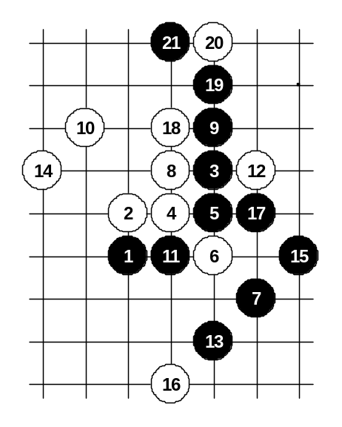
C, D:

← In the following two diagrams we can study both C and D variant at the same time because black win is exactly the same in both cases. Moves 15 and 17 is the beginning of black’s attack and 19, 21 are stopping white’s VCF with creating black’s VCF threat at the same time.
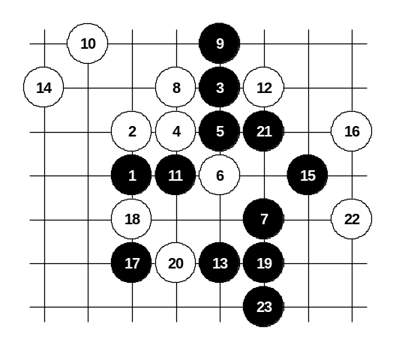

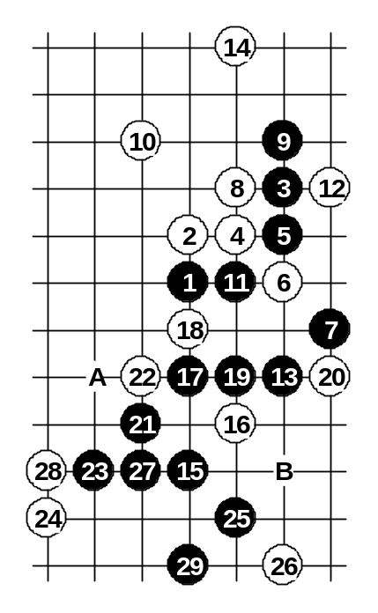
Another 16th move doesn’t save either. White’s 14th move is too far away and doesn’t help in defense. →

E:

← This 14th move was a really hard puzzle for me when I tried to search for black win. Finally I found the solution, but the variant is quite long. Black attack is complicated because of white’s counter-force. Until 22nd move white has no other choices. In move 22 white can try different stops but as a result, black wins after every one of them.
If 26-A then 27-B.
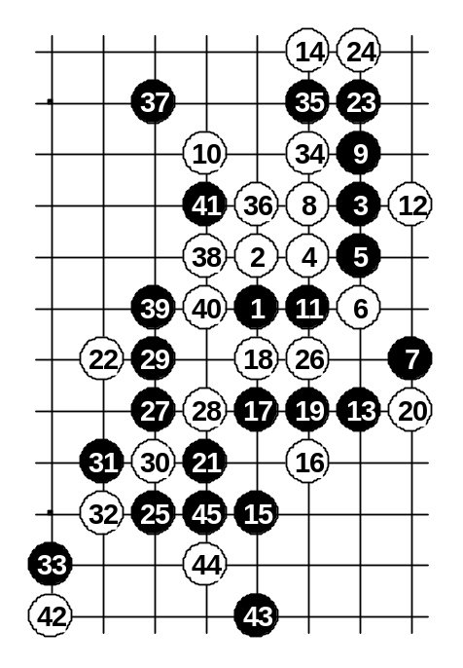
This 22nd move is the most challenging move. The following moves show the only black’s way to victory. As white’s counter-force is very dangerous, black should be very careful in every move. The 23rd move is a four, this is the only move that black can play. As a result, white VCF threat is eliminated. Black can go to attack now. The 25th – a simple and logical move. Moves 27 and 29 contain defensive function. After 31st move black has VCF threat and win. White’s attempt to cut the black VCF threat with moves 34, 36, 38, 40 does not bring any success because of simple 41st defense move. →
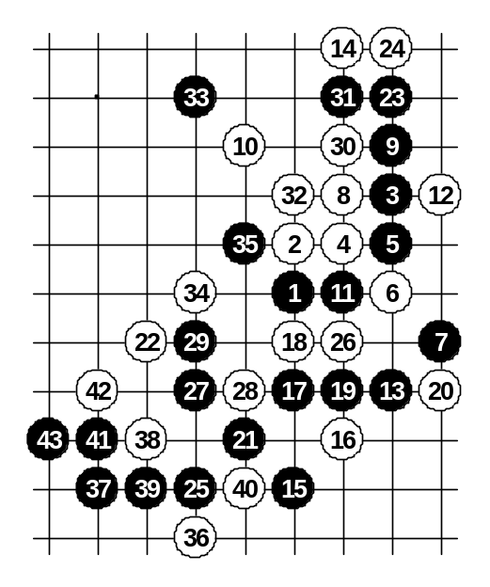

← Here is another way to stop the black’s three after move 29. Since black still has got VCF threat after 35th move, white is forced to stop below somewhere. Move 36-36 seems to be the strongest stop. However, black simple win follows with move 37-37 with standard attacking pattern.

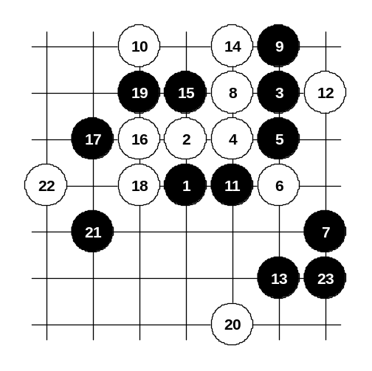
F:
This 14th move is the strongest move. Black does not have straight win after that. But on the other hand, this 14th move is not so useful for white’s activity, therefore simple 15th defense move here happens to be very strong.
The 16th move seems to be the best one, too. The 17th move is in same spirit with 15th – still defending and keeping the black attack in lower side stand by. Now white has no choice but switch to defense with moves 18 and 20. Here anyone can try different attacking ways for black. As an example, I suggest here the moves 21-21 and 23-23.
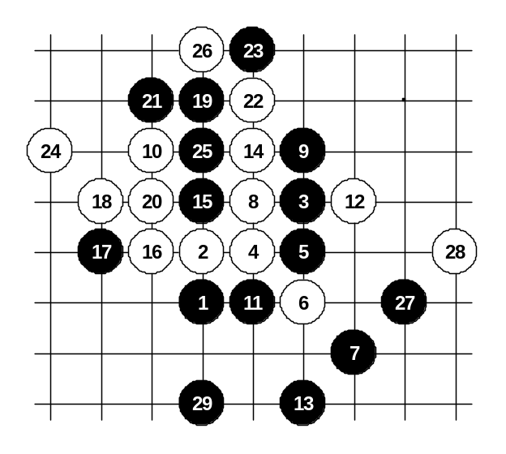
Here the diagram shows what will happen when white tries to play actively. As a result, white attack leads to white loss. Black easily eliminates the white’s attack and gets tempo and wins below. →

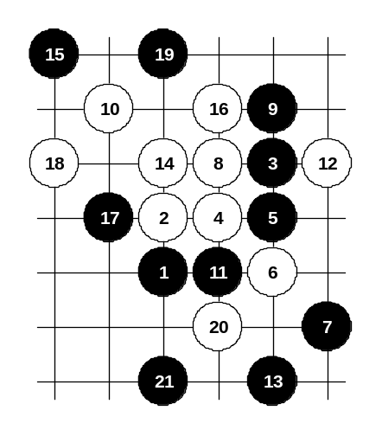

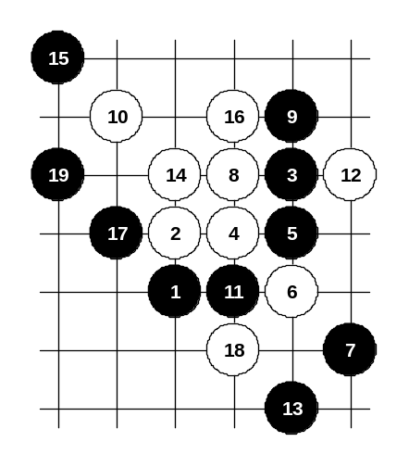
← If the passive stop was very good for black then we should also check what would happen when white plays the four into that point first. But as the white four has been played, black can play 17-17 now and the move 18-18 is not dangerous anymore. Black simply defends with move 19 and waits his victory below. The move 20 is just one of the best stops, but still useless.

Another 18th move. Black’s 19th move is very beautiful – black is finally attacking in the area that used to be good for white. Besides, black is about to continue the attack at point h6. →
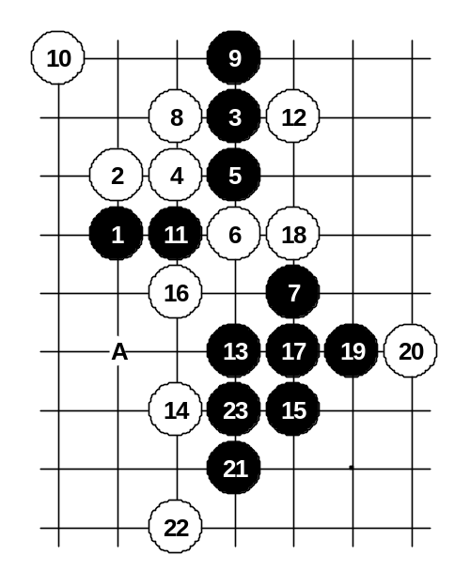
G, H:

← The G and H variants are about the white passive moves. After this 14th move black wins directly with 15-15.
If 14-16 then I think 15-A is a win move. You may study the possible continuations there by yourself.

